ST10291856 Mvelo Mkhize

3.

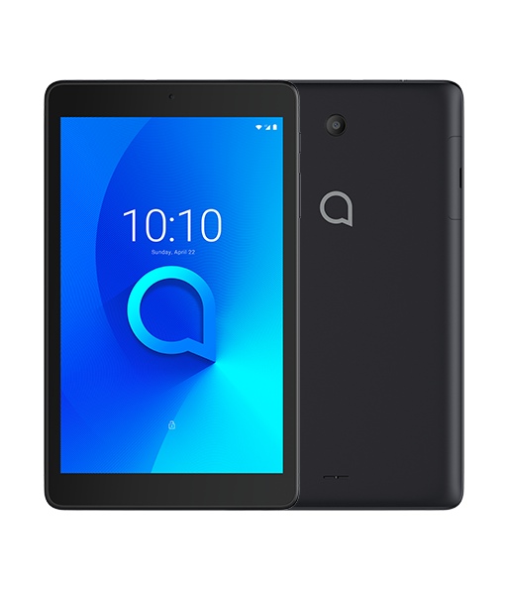

1. The Alcatel 3T 8 is a multimedia tablet produced and distributed by Alcatel with an 8 inch IPS LCD display.
2. My personal experience with this tablet has been mostly negative because the overall build quality is very bad. The plastic casing wasn’t slip resistant, the screen resolution was poor and too bright, the screen was very fragile, the speaker sounded very muffled and the camera was very low resolution.

The user interface was very poor and the response time was very slow, and the tablet comes with a lot of bloatware.

1. The Alcatel 3T 8 doesn’t complete all its user goals because it isn’t completely user friendly in terms of build quality and system usability.
2. Visibility – The navigation is basic, visible and easy for users to understand and use.

Consistency – The buttons and navigation all follow their designated functions.

Feedback – At almost every interaction the feedback will lag behind slightly.